Supplementary Fig. 1. Multi-omics and clinical correlation analysis of CRC liver metastasis signatures.
- Correlation heatmap showing the pairwise Pearson correlation coefficients between signature genes (rows) and lncRNAS (columns). The color scale represents correlation strength (red, positive correlation; blue, negative correlation), with values indicating correlation coefficients. (B) Non-negative matrix factorization (NMF) rank survey to determine the optimal factorization rank. Multiple metrics, including cophenetic correlation, dispersion, evar (explained variance), residuals, RSS (residual sum of squares), silhouette width, and sparseness, were evaluated across ranks 2–10 to identify the most stable and biologically meaningful decomposition. (C-D) Kaplan-Meier survival analysis comparing overall survival (OS) between patient subgroups stratified by the identified gene signature. (C) Two-group comparison; (D) Four-group comparison based on signature-based classification. The log-rank test p-values are shown, with tick marks indicating censored patients. (E) Box plots comparing the expression levels of metabolite across different patient subgroups (color-coded groups).

Supplementary Fig. 2. Quality control metrics of single-cell RNA-seq data across all samples and batches.
(A-C) Violin plots showing the distribution of key quality control metrics for cells from each sample in three independent batches: Batch 01 (A, GSE242889), Batch 02 (B, GSE189903), and Batch 03 (C, GSE189903). The metrics include the number of detected genes (nFeature_RNA), total UMI counts (nCount_RNA), percentage of mitochondrial gene expression (percent.mt), and percentage of gene expression (percent.rb). All samples passed the pre-defined quality control thresholds, with no cells showing excessively high mitochondrial gene expression or low gene detection rates.

Supplementary Fig. 3. In data dimension reduction analysis, the effects corresponding to different PC numbers are displayed.
A total of 1-29 PC numbers were attempted. A single PC is represented by the top 10 genes.

Supplementary Fig. 4. Multi-stage analysis and results of single cell.
- The clustering tree reflected the difference in the number of different cell clusters. (B) The relative spatial distribution and quantity proportion of multiple cell groups were visualized. (C) The 9 cell groups correspond to the overall proportion. (D) Markers used in the annotation process. (E) The bubble diagram shows the key markers used in subgroup annotation.

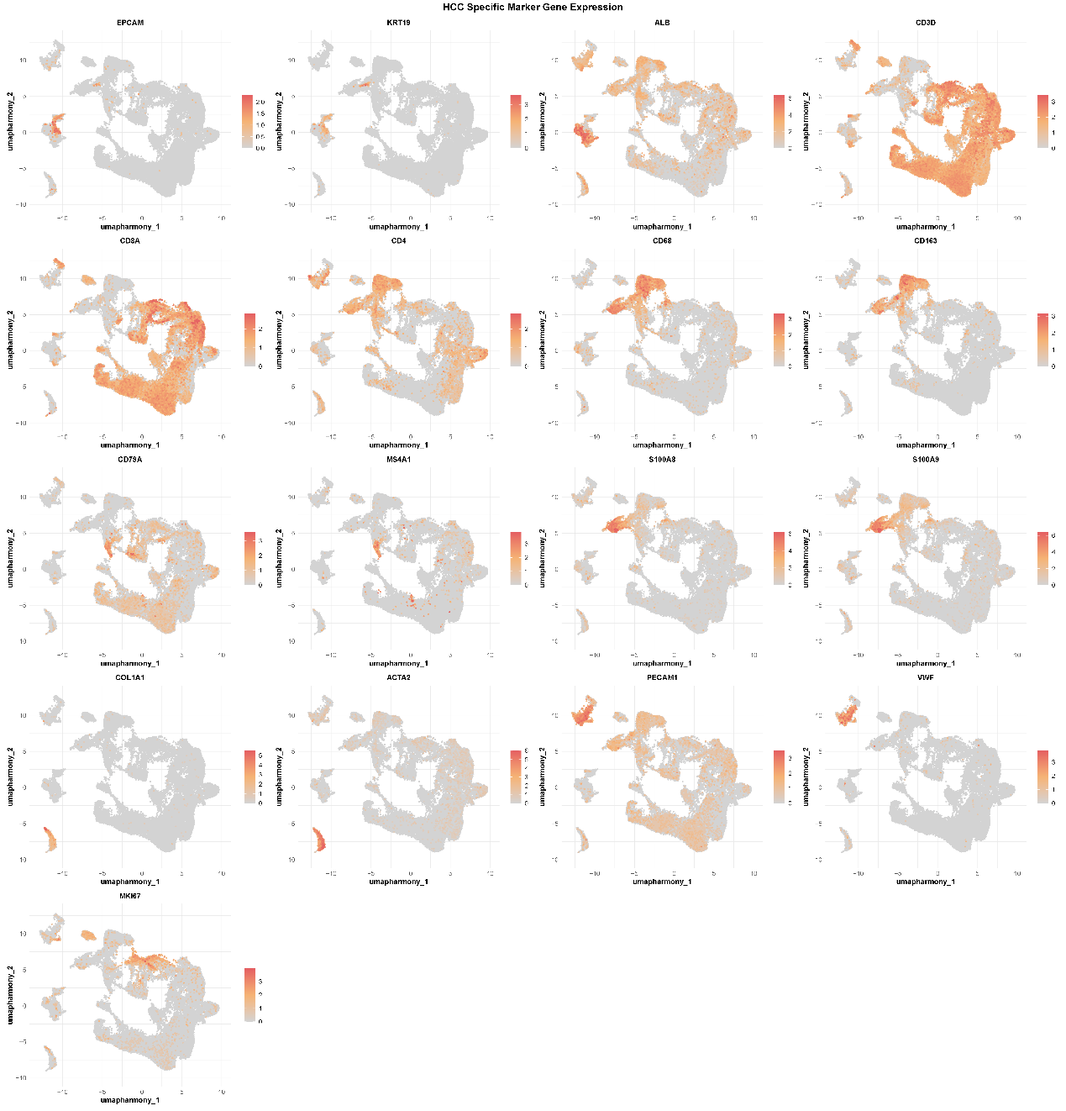
Supplementary Fig. 5. The expression and distribution of key cell markers on UMAP map
The UMAP diagram reflects the expression trend of different markers, and suggests the spatial position of the corresponding cells.

Supplementary Fig. 6. Regrouping of tumor cells from the perspective of disulfidptosis
- The expression distribution of disulfide death-related genes in different cell populations. (B) The results of tumor cell clustering were clear, based on the disulfide death score. (C) The volcano plot of the different expression genes between two groups.
Supplementary Fig. 7. Trajectory analysis of MDSCs subsets and tracking of gene expression trend
Cell cluster trajectory analysis of three kind of cells. (A) Monocle 3 analysis of MDSCs trajectories-state. (B-H) Monocle analysis of significantly differentially expressed genes in pseudo-time.

Supplementary Fig. 8. Correlation analysis of multiple scores in macrophages and tumor cells
- The expression and distribution of key ligands and receptors in the cell communication axis between different cells. (B) The different intensity of the interaction axis between tumor cells and M2 macrophages was demonstrated. (C) The violin plot shows the intensity score distribution of the three biological stages related to disulfide death in macrophages. (D and E) The correlation distribution between disulfide death score and ferroptosis score in different cell populations. (F-H) The correlation strength of GPX4, RAC1 and SLC7A11 was compared.

